

***OLIVER TRAY SEALER***

***Model 1208-C***

User’s operating and instruction manual

**Section description Page**

DESCRIPTION/SPECIFICATIONS 5

GENERAL SAFETY INSTRUCTIONS 6

NAMEPLATES/PICTOGRAMS PART LIST 7

NAMEPLATES/PICTOGRAM LOCATION

BY ITEM NUMBER 8

BASIC MACHINE COMPONENTS AND SET UP 9

OPERATING PROCEDURES 11

ADJUSTMENT AND QUALITY 12

TECHNICAL SPECIFICATIONS 13

CLEANING AND MAINTENANCE 14

TROUBLE SHOOTING 17

WIRING DIAGRAM 18

DIAGRAM 19

PARTS LIST 20

MoDEL 1208 CARRIER 21

WARRANTY 22

WARRANTY PROCEDURE 23

Index

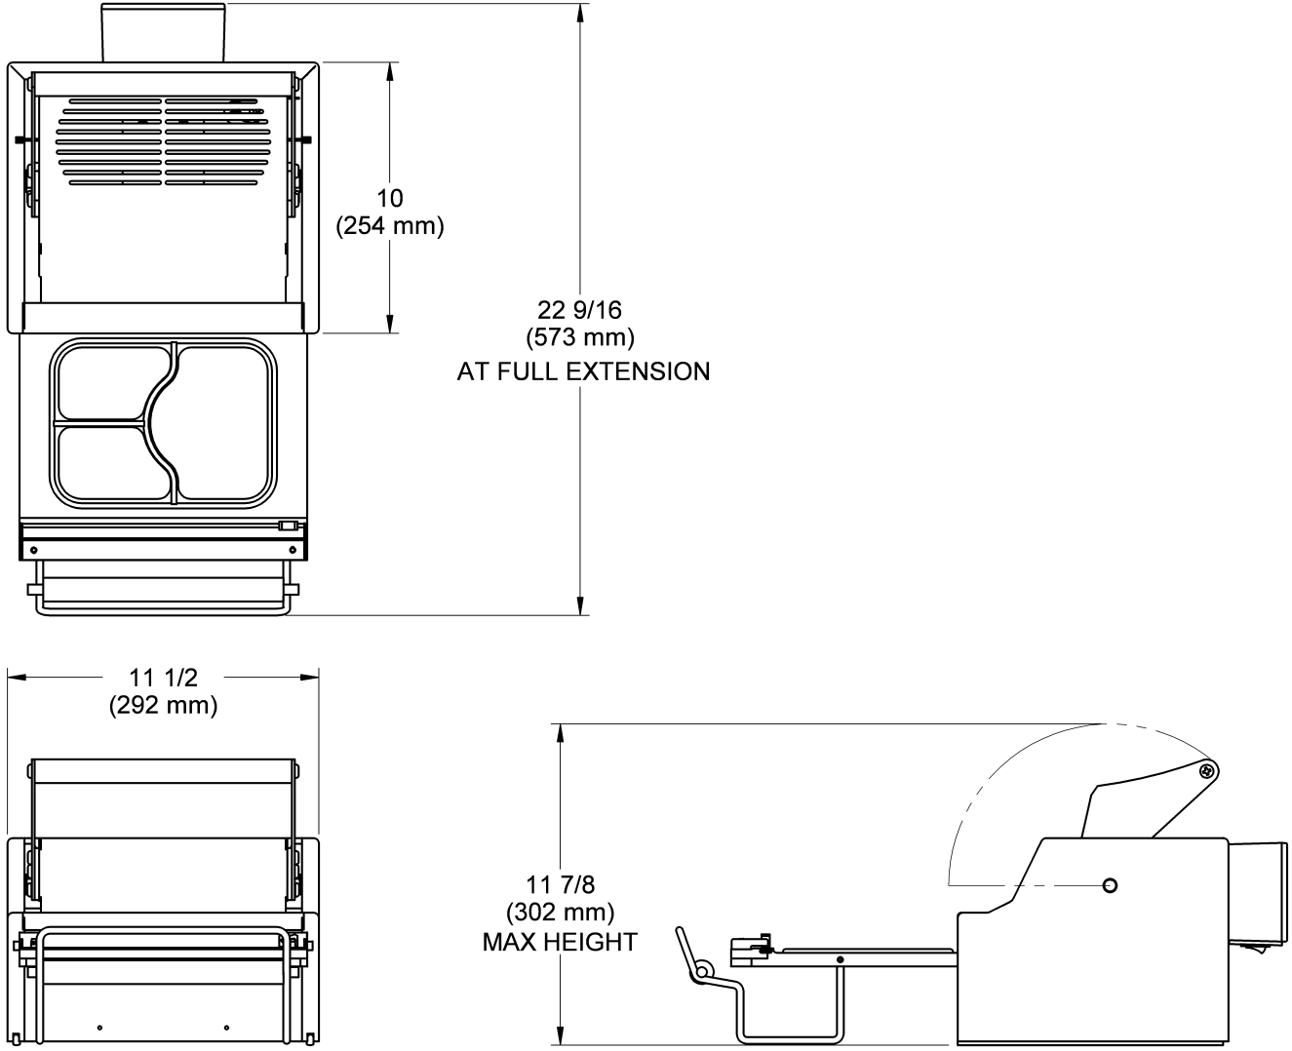

Description/Specifications

Description

The Oliver Model 1208-C Heat Sealer is designed and manufactured to ensure a user friendly operation of producing film lidded trays with a cost effective approach.

The manually operated machine operates with a 120 V.A.C. outlet. The machine was designed to be a compact to limit the amount of table space needed to operate.

Specifications

*Space Requirements, (Shown complying with European Standards)*

***Model 1208-C*** *(All dimensions are shown approximate)*

Shipping Weight – 22 lbs. (approximate)

Net Weight – 18 (approximate)

**IT IS ESSENTIAL THAT ALL OPERATORS AND MAINTENANCE PERSONNEL OBSERVE THE FOLLOWING SAFETY PRECAUTIONS. IMPROPER INSTALLATION, MAINTENANCE, OR OPERATION OF THIS EQUIPMENT MAY CAUSE SERIOUS INJURY.**

1. Read this manual before attempting to operate your heat sealer. Never allow an untrained person to operate or service this unit.
2. Observe all caution and warning labels affixed to the machine.
3. Always unplug the machine before cleaning or servicing.
4. Do not submerge in water. Do not hose down.
5. Use original replacement parts.

6. Wear proper, personal, protective, safety equipment if necessary.

7. Keep hands away from moving parts of the machine while it is operating.

1. In addition to these general safety instructions, please follow the more specific

safety instructions provided throughout the rest of this operating and instruction manual.

**DO NOT USE FOR OTHER THAN ORIGINALLY INTENDED PURPOSE.**

It is very important that the unit should be free of any unexpected energization, or be able to release hazardous energy during service or maintenance activities.

Therefore, always switch the machine off before unplugging the power cord from **BOTH** the unit and the wall.

**WARNING**

**WARNING**

General safety instructions

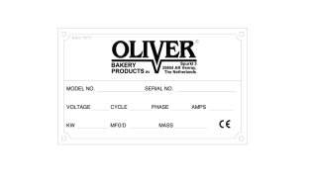

**ITEM NO PART DESCRIPTION PART NUMBER**

**_______________________________________________________________________________________________________________________________________________________________**

601 “OLIVER” 6401-5076

603 “STAY CLEAR” 6401-9043

604 “CONSULT OPERATOR...” 6400-3039

605 “ELECTRICAL SHOCK” 6400-5009

606 “UNPLUG BEFORE OPENING" 6402-1028

607 “HOT SURFACE” 6400-8021

**\*\*SEE PAGE 8 FOR NAMEPLATE LOCATIONS BY ITEM NUMBER**

Nameplate/pictogram part list

(international models only)

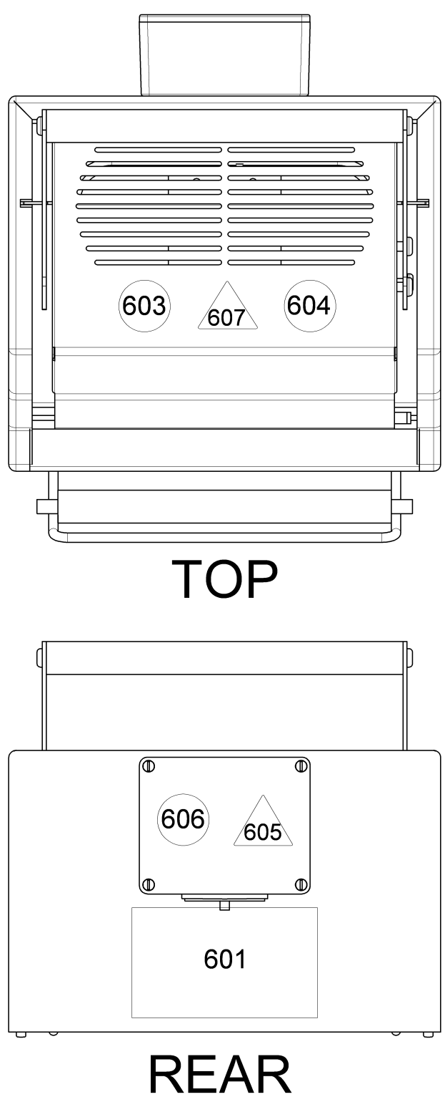

Nameplate/pictogram locations by item number

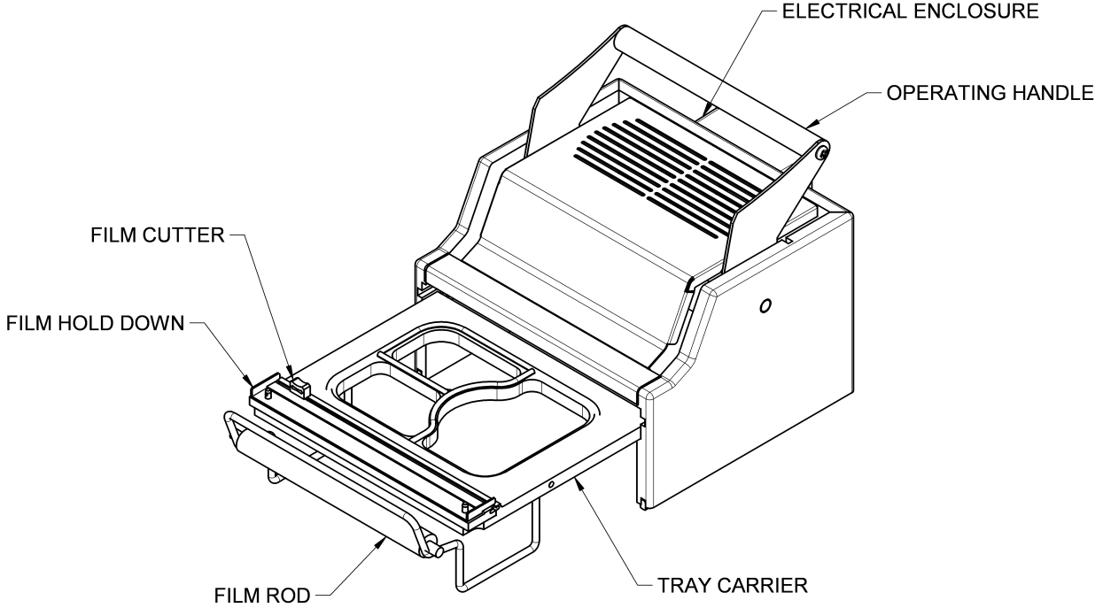

Basic machine components and set up

Before proceeding further, take a moment to familiarize yourself with the identification of the machine components as shown in the illustration below.

**SET UP**

1. Carefully remove the Model 1208-C from the box. Check to make sure the order is complete, and it has not been damaged during shipment.
2. Place the unit in a suitable location which provides an adequate working space. The location must be sturdy, level, and capable of holding 18 lbs. per machine.

1. Remove all packaging materials and shipping restraints such as plastic ties and tape.
2. Raise the handle to full extension.
3. Place film rod into the center of the roll of film.
4. Place film on the machine, and thread film through the film hold down, as shown below.

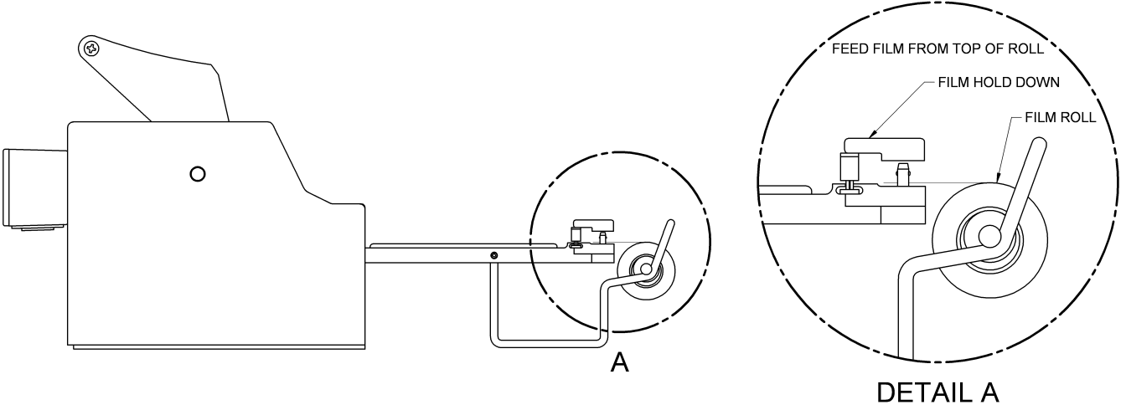

**NOTE**

Set up (continued)

**FILM SUPPLIED BY OLIVER PRODUCTS COMPANY IS WOUND WITH THE ADHESIVE SIDE IN.**

**FEED FILM FROM THE TOP OF THE ROLL AS SHOWN IN DETAIL ‘’A’’.**

**CAUTION**

Operating procedures

1. Plug the power cord into a properly grounded outlet. Avoid the use of extension cords.

**NOTE:** It should take approximately 15 minutes for the machine to warm up to operating temperature.

1. Slide tray carrier out until it stops.
2. Place filled tray in tray carrier. Make sure the food in the tray is not higher than the flange of the tray
3. Grasp the corners of the film and pull it straight across the tray going a ¼ inch past the flange of the tray.
4. Push tray carrier in gently until it stops.
5. Pull handle down with both hands until it stops. Hold the handle down for approximately 2 seconds.
6. Lift the handle to its upright position.
7. Pull tray carrier out.
8. Apply pressure to the film hold down bar with index finger, and with the other hand gently slide the cutter from one side to the other with minimal pressure.
9. Remove tray from tray carrier.
10. Repeat steps 4 thru 11.

**IT IS NOT RECOMMENDED TO LEAVE THE MACHINE ON WHEN IT WILL BE OUT OF OPERATION FOR AN EXTENDED PERIOD OF TIME.**

Your OLIVER Model 1208-C was tested at the factory using Oliver trays and film.

* THE TEMPERATURE CANNOT BE ADJUSTED BY THE OPERATOR
* THE PRESSURE CANNOT BE ADJUSTED BY THE OPERATOR

The heater platen temperature is factory set at approximately 300°F (Approx. 150°C). Contact the Oliver Service Department if you suspect the heated platen temperature is not correct.

It is necessary to periodically check for a proper seal. This can be done by pull the film over the empty tray carrier, sealing it like normal and pulling the film. If there is a proper seal, the pattern on the film should be a complete outline of the edges of the tray.

A poor seal will occur if the product in the tray contaminates the tray flange. Moisture will have the same affect on the seal. Trays that have irregular flanges or are deformed also seal poorly. Defective trays should be discarded.

Under different operating conditions, it may be necessary to increase or decrease the sealing time. This is done by varying the length of time the operating handle is in the down position. Holding the handle down longer makes the seals stronger. Although a stronger seal may cause shredding or tearing of the film when removing film from tray.

**NOTE**

Adjustment and quality

Technical specifications

* Temperature Range: Factory preset to approx. 300°F/150°C
* Weight: 18 lbs
* Electrical: 120 volts AC (USA) 2 Amps (1.7A drawn),

50-60 Hz

* Finish: White Pebble / Stainless steel
* Max roll diameter: 2’’ OD
* Max roll width: 8.875’’
* Std. seal area: 8.5’’ x 6.5’’
* Max seal area: 7’’ x 8.875’’
* Std. gaskets: White/60 duro/ approximately 1/8” seal
* Handle pull down: 15lb to 20lb
* Dielectric breakdown: 1250 for one second
* Constructed of: White HDPE / Stainless steel / Aluminum
* These cleaning recommendations are not meant to replace plant standard manufacturing procedures or regulatory requirements.
* If the machine has been in operation, allow the unit to cool before cleaning.
* Do not submerge unit in water. Do not wash down
* Tray carrier is NOT recommended for automatic dishwashers
* **CAUTION HOT:** The heated platen is **HOT!** Caution must be used to prevent injury from heated platen.
* Make sure the unit has been unplugged for a minimum one hour before cleaning.
* It is important that the surface of the heater platen is kept clean and smooth. Regularly clean the *OLIVER Model 1208-C* with a mild cleaner and a damp cloth. If food product comes in contact with the surface of the platen, it tends to burn on and become hard. This results in an irregular surface on the face of the platen which can result in poor seals. If this happens, it will be necessary to remove this contaminate material. When cleaning care must be taken to avoid scratching or gouging the surface of the platen. **DO NOT SCRAPE THE SURFACE OF THE PLATEN WITH SHARP OBJECTS AND AVOID THE USE OF METAL TOOLS**. The use of plastic or soft-metal scouring pads such as SCOTCH BRITE™ or CHORE BOY® provides a safe and effective means of cleaning the platen. Be sure to wipe all surfaces with a sanitizing agent after cleaning.
* IF IT IS NECESSARY TO CLEAN THE PLATEN WHILE IT IS STILL HOT ALTHOUGH NOT RECOMMENDED, BE SURE TO USE A HOT PAD GLOVE TO PROTECT YOUR SKIN.

**WARNING**

**CAUTION**

**CAUTION**

**NOTE**

Cleaning and maintenance

Cleaning and maintenance (continued)

**CLEANING PROCEDURES**

1. Remove tray carrier by pushing the carrier in, filling the tray carrier straight up, and then pull out.
2. Wipe down tray carrier and gaskets with a standard cleaning solution.
3. Tip the machine up on its side, and then wipe off the heated platen.
4. Wipe sides, top and handle of the machine.
5. Replace tray carrier

**CHANGING CUTTER BLADE**

1. Remove tray carrier, as described above.
2. Use a flat head screw driver to remove one of the screws on either end of the cutter track
3. Replace old cutter with new.
4. Replace and retighten screws.

Cleaning and maintenance (continued)

**REPLACING AND CHECKING GASKETS**

* If there are any gouges, cuts or gaps in the gasket, the gasket will have to be replaced.
* Be sure to replace all the gaskets not just the piece that is damaged.
* When reinstalling gaskets, the gasket must be seated all the way down in the

groove.

* Do not stretch gasket when reinstalling.
* After the new gaskets are installed, place the tray carrier up side down on a flat surface and check to see if the newly installed gasket is even.
* If not even, depress or lift gasket to provide an even heat sealing surface.
* It is necessary to periodically check for a proper seal. This can be done by pull the film over the empty tray carrier, sealing it like normal and pulling the film. If there is a proper seal, the pattern on the film should be a complete outline of the edges of the tray.

**DISPOSAL PROCEDURE**

When considering disposing of your unit, please contact local authorities for any special instructions.

**SYMPTOM CORRECTIVE ACTION**

#### Poor seal quality Verify that the platen is heated and is at the correct temperature (approximately 300°F/150°C)

Check to see if the platen is dirty

Check rubber gasket on tray holder for damaged or missing pieces

_______________________________________________________________________

Platen does not heat up Verify that the power cord is plugged into outlet

Verify that the power switch is in the “on “position

Verify that there is power at the outlet

_______________________________________________________________________

Film does not cut Check that the film is threaded properly

Be sure the film hold down bar is in place above

the film

_______________________________________________________________________

Film sticking to heater Film is coming off the roll the wrong direction or

improper threading.

_______________________________________________________________________

Shredding film Holding sealer down for more than 2 sec.

may cause this.

Trouble shooting

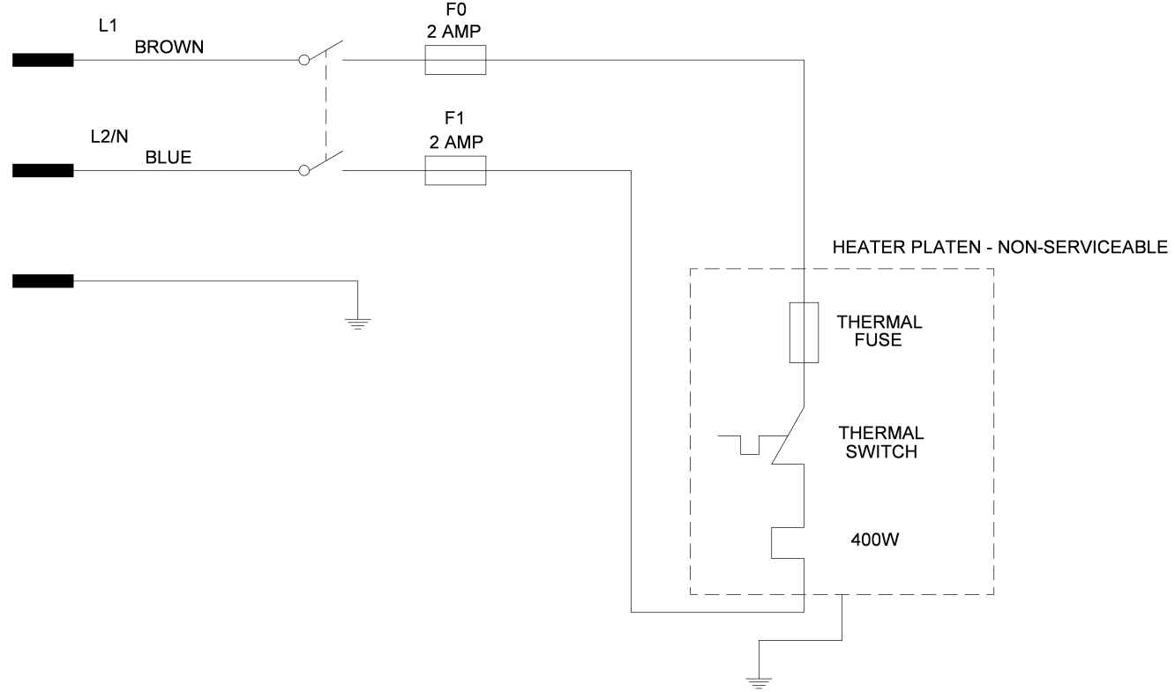

Wiring diagram

**1-60-120V**

**REF. W/D 1308C12002**

**(REFERENCE W/D 1208C12003)**

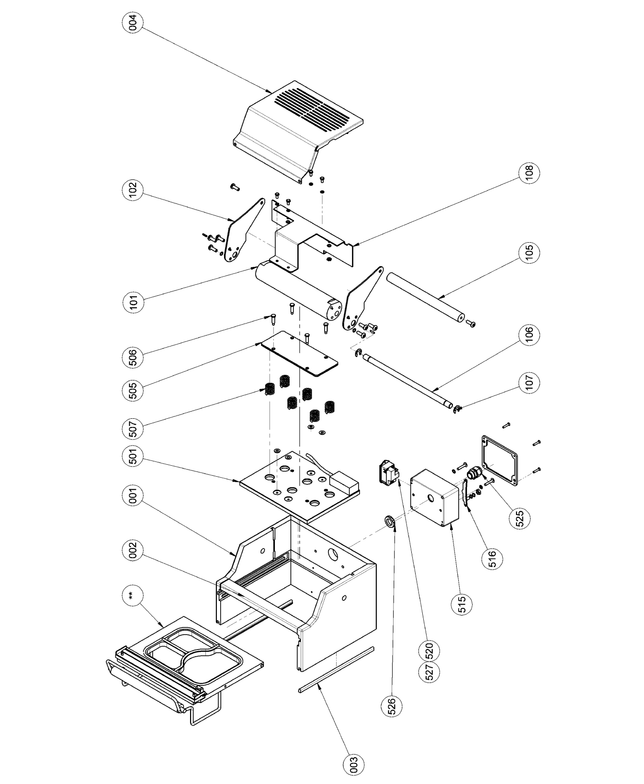

Diagram

**ITEM NO PART DESCRIPTION PART NUMBER**

001 Frame Assembly 1208-0001-101

002 Spacer-Front 1208-0001-0043

003 Cushion Gray Silicone Extruded 6516-0020

004 Cover 1208-0009-001

101 Cam-Pusher 1208-0005

102 Arm 1208-0006

105 Handle-Arm 1208-0007

106 Shaft-Cam 1208-0010

107 Ring-Retaining 5840-1280

108 Lifter-Cam 1208-0008-001

501 Plate-Heater (230V) 1208-0033-101

505 Retainer Spring Plate 1208-0019

506 Screw 1/4” Diameter x 3/4" Shoulder 4560-0908-1201

507 Spring-Compression 7014-3106

515 Enclosure-Electrical 1208-0032-2

516 Brace-Ground 1208-0036-1

520 Inlet-Fused Power w/ Switch 5746-7911

521* Fuse-5 x 20 mm (250V) 5725-9500

525 Relief-Strain 5765-1110

526 Nut-Strain Relief 5766-7786

527 Fuse Drawer 5746-7951

* **Item not shown**

Parts list

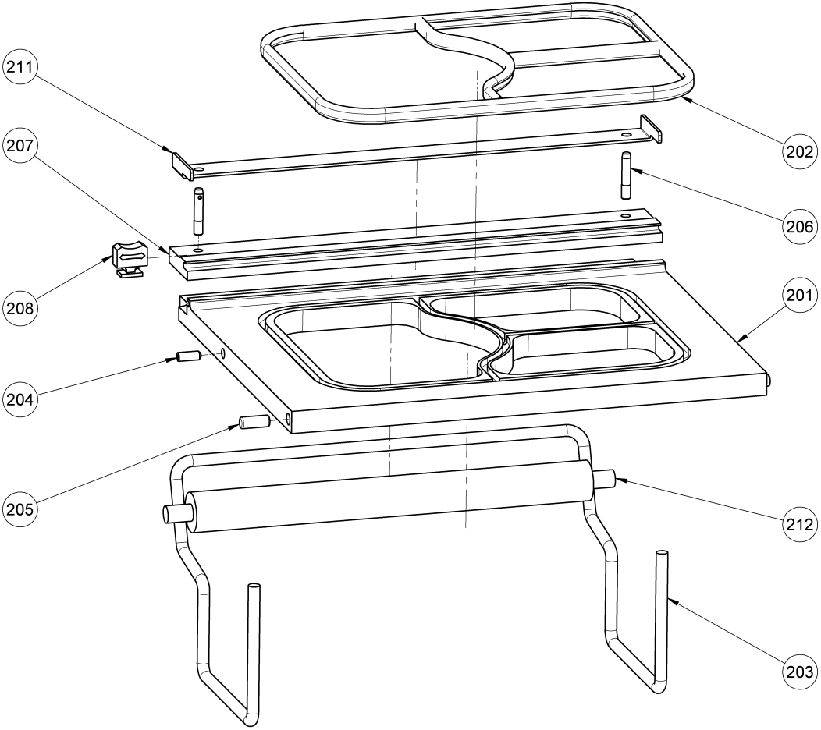

**MODEL 1208-C TRAY CARRIER PARTS LISTS**

**ITEM NO PART DESCRIPTION PART NUMBER**

201 Carrier-Tray 3 Compartment 1208-0013-512

202 Cushion-White Silicone Extruded 6516-0028

203 Rod-Film Holder 1208-0014

204 Screw-10-24 x 1” STST Set 5843-2024

205 Pin-1/4” x 5/8” STST Dowel 5835-6474

206 Pin-3/16” x 1/2” STST Quick Release 5835-7800

207 Slitter-T-Slot 1208-0016-001

208 Cutter-Slide 5903-5600

211 Hold Down-Film 1208-0012-001

212 Tube-Film 1208-0015

FOR SERVICE PARTS CALL SOLPAK AT 1-877-476-5725

Model 1208-C carrier

Warranty

PARTS

Oliver Packaging & Equipment Company (Oliver) warrants that if any part of the equipment (other than a part not manufactured by Oliver) proves to be defective (as defined below) within one year after shipment, and if Buyer returns the defective part to Oliver within one year, Freight Prepaid to Oliver’s plant in Grand Rapids, MI, then Oliver, shall, at Oliver’s option, either repair or replace the defective part, at Oliver’s expense.

LABOR

Oliver further warrants that equipment properly installed in accordance with our special instructions, which proves to be defective in material or workmanship under normal use within one (1) year from installation or one (1) year and three (3) months from actual shipment date, whichever date comes first, will be repaired by Oliver or an Oliver Authorized Service Dealer, in accordance with Oliver’s published Service Schedule.

For purposes of this warranty, a defective part or defective equipment is a part or equipment which is found by Oliver to have been defective in materials workmanship, if the defect materially impairs the value of the equipment to Buyer. Oliver has no obligation as to parts or components not manufactured by Oliver, but Oliver assigns to Buyer any warranties made to Oliver by the manufacturer thereof.

This warranty **does not** apply to:

1. Damage caused by shipping or accident.

2. Damage resulting from improper installation or alteration.

3. Equipment misused, abused, altered, not maintained on a regular basis, operated carelessly, or used in abnormal conditions.

4. Equipment used in conjunction with products of other manufacturers unless such use is approved by Oliver Products in writing.

5. Periodic maintenance of equipment, including but not limited to lubrication, replacement of wear items, and other adjustments required due to installation, set up, or normal wear.

6. Losses or damage resulting from malfunction.

The foregoing warranty is in lieu of all other warranties expressed or implied AND OLIVER MAKES NO WARRANTY OF MERCHANTABILITY OR FITNESS FOR PURPOSE REGARDING THE EQUIPMENT COVERED BY THIS WARRANTY. Oliver neither assumes nor authorizes any person to assume for it any other obligations or liability in connection with said equipment. OLIVER SHALL NOT BE LIABLE FOR LOSS OF TIME, INCONVENIENCE, COMMERCIAL LOSS, INCIDENTAL OR CONSEQUENTIAL DAMAGES.

Warranty procedure

1. If a problem should occur, call SOLPAK at 1-877-476-5725 ext. 221
2. A Solpak partner will determine if the warranty will apply to this particular problem and inform you of the actions to take (technician, exchange,…).
3. A replacement 1208 can be made available to you in the event your unit has to be repaired in our service centre.

***The Solpak team***

***thanks you for your trust!***