

***OLIVER TRAY SEALER***

***Models 1308-C and 1308-N***

User’s operating and instruction manual

**Section description Page**

DESCRIPTION/SPECIFICATIONS 5

GENERAL SAFETY INSTRUCTIONS 6

NAMEPLATES/PICTOGRAMS PART LIST 7

NAMEPLATES/PICTOGRAM LOCATION

BY ITEM NUMBER 8

BASIC MACHINE COMPONENTS AND SET UP 9

OPERATING PROCEDURES 11

ADJUSTMENT AND QUALITY 12

TECHNICAL SPECIFICATIONS 13

CLEANING AND MAINTENANCE 14

TROUBLE SHOOTING 17

WIRING DIAGRAM 18

DIAGRAM 19

PARTS LIST 20

MoDEL 1308 CARRIER 22

WARRANTY 23

WARRANTY PROCEDURE 24

Index

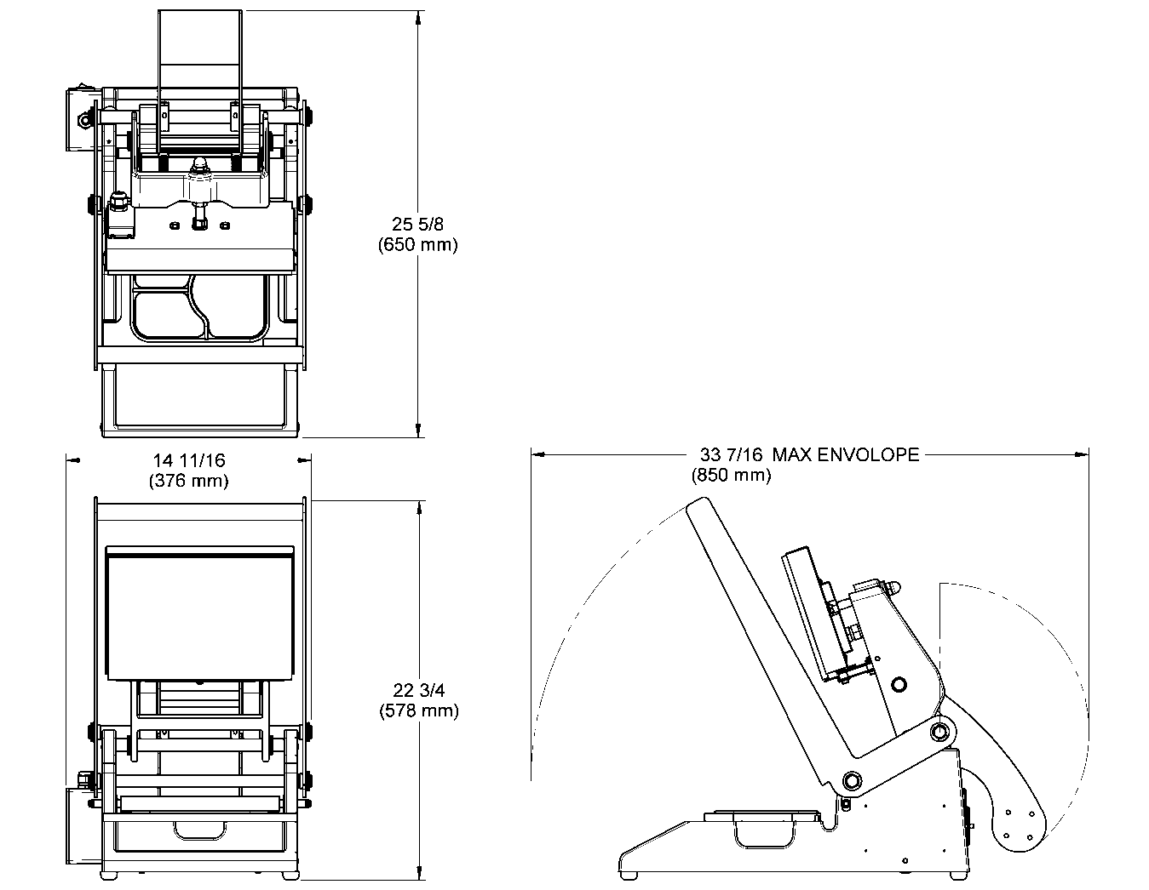

Description/Specifications

Description

The Oliver Model 1308 Heat Sealer is designed and manufactured to ensure a user friendly operation of producing film lidded trays with a cost effective approach.

The manually operated machine operates with a 120 V.A.C. outlet. The machine was designed to be compact to limit the amount of table space needed to operate.

Specifications

*Space Requirements, (Shown with standard options)*

***Model 1308-C & 1308-N*** *(All dimensions are shown approximate)*

Shipping Weight – 65 lbs (30 Kg) (approximate)

Net Weight – 60 lbs (27 Kg) (approximate)

**IT IS ESSENTIAL THAT ALL OPERATORS AND MAINTENANCE PERSONNEL OBSERVE THE FOLLOWING SAFETY PRECAUTIONS. IMPROPER INSTALLATION, MAINTENANCE, OR OPERATION OF THIS EQUIPMENT MAY CAUSE SERIOUS INJURY.**

1. Read this manual before attempting to operate your heat sealer. Never allow an untrained person to operate or service this unit.
2. Observe all caution and warning labels affixed to the machine.
3. Always unplug the machine before cleaning or servicing.
4. Do not submerge in water. Do not hose down.
5. Use original replacement parts.

6. Wear proper, personal, protective, safety equipment if necessary.

7. Keep hands away from moving parts of the machine while it is operating.

1. In addition to these general safety instructions, please follow the more specific

safety instructions provided throughout the rest of this operating and instruction manual.

**DO NOT USE FOR OTHER THAN ORIGINALLY INTENDED PURPOSE.**

It is very important that the unit should be free of any unexpected energization, or be able to release hazardous energy during service or maintenance activities.

Therefore, always switch the machine off before unplugging the power cord from **BOTH** the unit and the wall.

**WARNING**

**WARNING**

General safety instructions

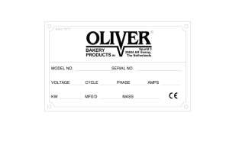

**ITEM NO PART DESCRIPTION PART NUMBER**

**_______________________________________________________________________________________________________________________________________________________________**

601 “OLIVER” 6401-5076

603 “STAY CLEAR” 6401-9043

604 “CONSULT OPERATOR...” 6400-3039

605 “ELECTRICAL SHOCK” 6400-5009

606 “UNPLUG BEFORE OPENING" 6402-1028

607 “HOT SURFACE” 6400-8021

**\*\*SEE PAGE 8 FOR NAMEPLATE LOCATIONS BY ITEM NUMBER**

Nameplate/pictogram part list

(international models only)

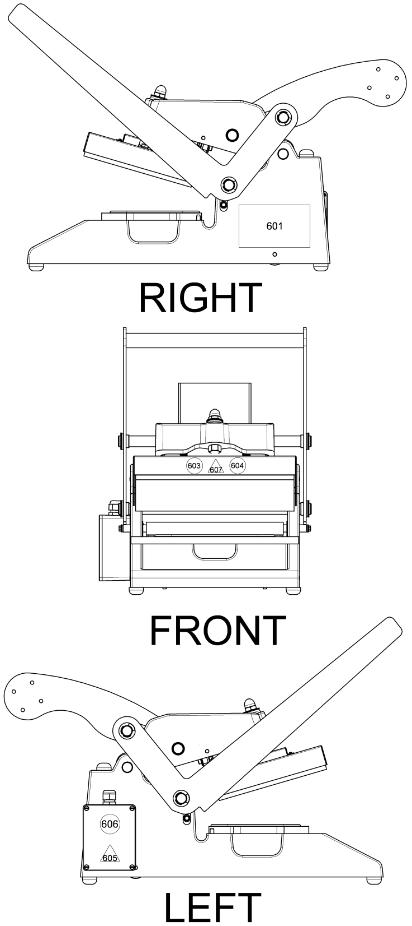

Nameplate/pictogram locations by item number

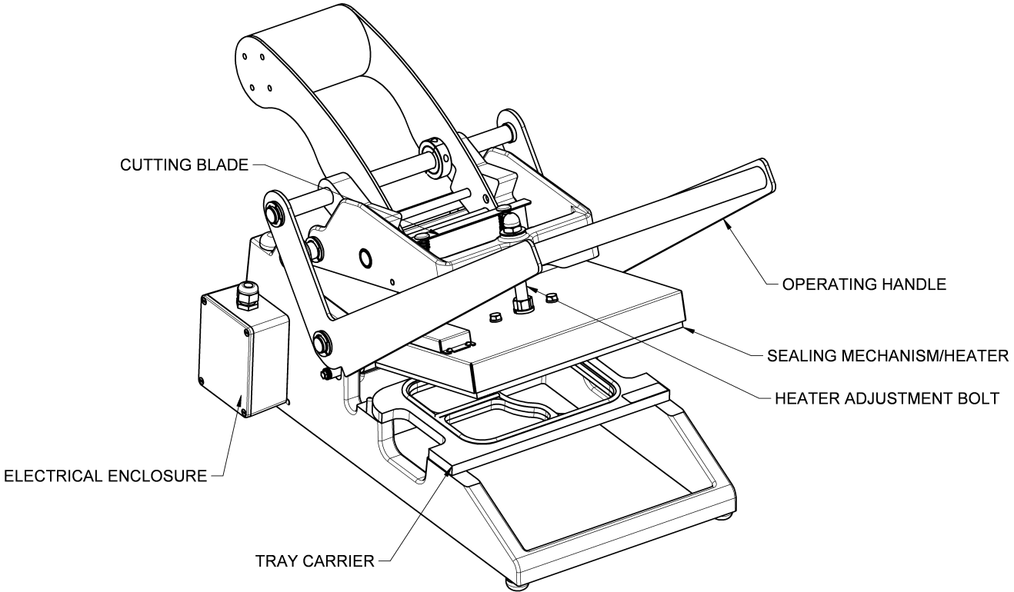

Basic machine components and set up

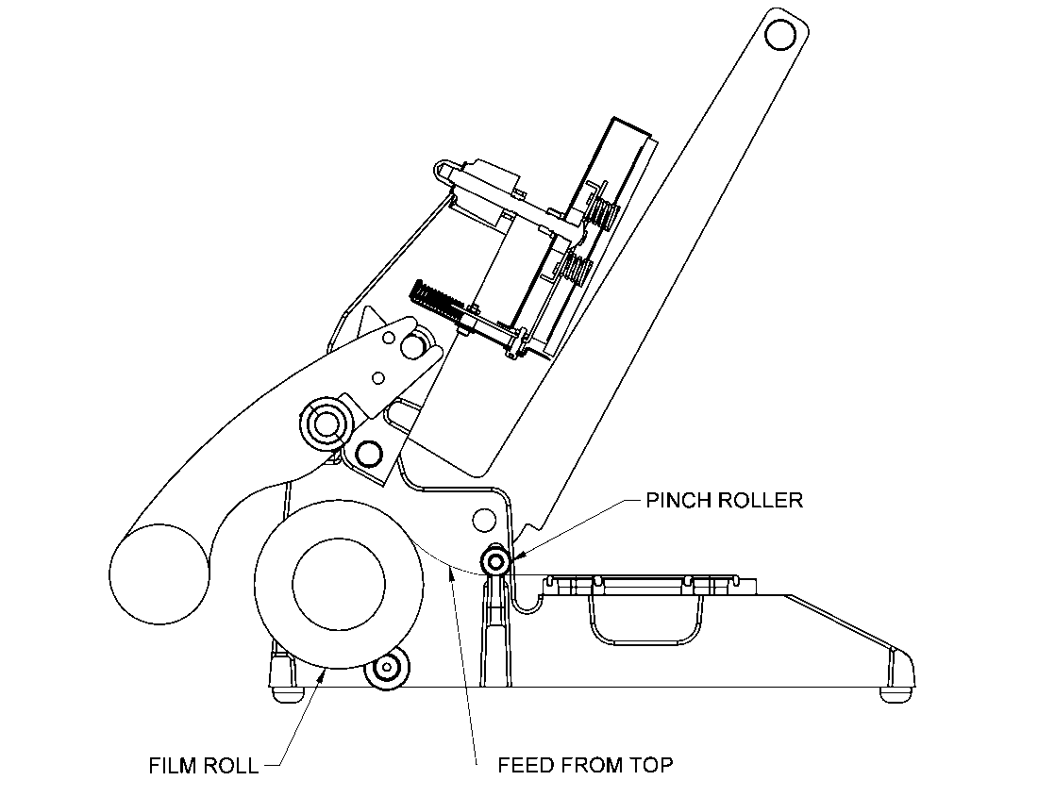

**FILM SUPPLIED BY OLIVER PRODUCTS COMPANY IS WOUND WITH THE ADHESIVE SIDE IN.**

**FEED FILM FROM THE TOP OF THE ROLL AS SHOWN.**

**NOTE**

Set up (continued)

**CAUTION**

1. Plug the power cord into a properly grounded outlet. Avoid the use of extension cords.
2. Pusher rocker switch to “On” position (red light indicates on).

**NOTE:** It should take approximately 15 minutes for the machine to warm up to operating temperature.

1. Place tray carrier in its designated area with the dowel pins facing down
2. Place filled tray in tray carrier. Make sure the food in the tray is not higher than the flange of the tray
3. Grasp the corners of the film and pull it straight across the tray going a 1⁄4 inch past the flange of the tray
4. Pull handle down with both hands until it stops. Hold the handle down for approximately 2 seconds.
5. Lift the handle to its upright position.
6. Remove tray from tray carrier.
7. Repeat steps 4 thru 8.

**IT IS NOT RECOMMENDED TO LEAVE THE MACHINE ON WHEN IT WILL BE OUT OF OPERATION FOR AN EXTENDED PERIOD OF TIME.**

Operating procedures

Your OLIVER Model 1308 was tested at the factory using Oliver trays and film.

* THE TEMPERATURE CANNOT BE ADJUSTED BY THE OPERATOR

The heater platen temperature is factory set at approximately 300°F (Approx. 150°C). Contact the Oliver Service Department if you suspect the heated platen temperature is not correct.

It is necessary to periodically check for a proper seal. This can be done by pull the film over an empty tray carrier, sealing it like normal and peeling the film. If there is a proper seal, the pattern on the film should be a complete outline of gasket material provided.

A poor seal will occur if the product in the tray contaminates the tray flange or the pressure generated by the sealing mechanism is less than 15lbs. The pressure can be

adjusted by removing the acorn nut atop the center arm and giving a few turns to the nut on the heater adjustment bolt. This will expose more threads between the casting and the sealing mechanism, therefore, generating more pressure.

Under different operating conditions, it may be necessary to increase or decrease the sealing time. This is done by varying the length of time the operating handle is in the down position. Holding the handle down longer makes the seals stronger. Although a stronger seal may cause shredding or tearing of the film when removing film from tray.

**NOTE**

Adjustment and quality

Technical specifications

* Temperature Range: Factory preset to approx. 300°F/150°C
* Weight: 60 lbs (27 kg)
* Electrical: 120 volts AC (USA) 4 Amps (3.4A drawn),

60 Hz

* Finish: White Powder Coat / Stainless steel
* Max roll diameter: 5-1/2’’ COD
* Max roll width: 9’’
* Std. seal area: 9’’ x 6.375’’
* Max seal area: 9’’ x 7.5’’
* Std. gaskets: White/60 duro/ approximately 1/8” seal
* Handle pull down: 15lb to 20lb
* Dielectric breakdown: 1250 for one second
* Constructed of: Cast Aluminum/Stainless steel
* These cleaning recommendations are not meant to replace plant standard manufacturing procedures or regulatory requirements.
* If the machine has been in operation, allow the unit to cool before cleaning.
* Do not submerge unit in water. Do not wash down.
* Tray carrier is NOT recommended for automatic dishwashers.
* **CAUTION HOT:** The heated platen is **HOT!** Caution must be used to prevent injury from heated platen.
* Make sure the unit has been unplugged for a minimum one hour before cleaning.
* It is important that the surface of the heater platen is kept clean and smooth. Regularly clean the *OLIVER Model 1308* with a mild cleaner and a damp cloth. If food product comes in contact with the surface of the platen, it tends to burn on and become hard. This results in an irregular surface on the face of the platen which can result in poor seals. If this happens, it will be necessary to remove this contaminate material. When cleaning care must be taken to avoid scratching or gouging the surface of the platen. **DO NOT SCRAPE THE SURFACE OF THE PLATEN WITH SHARP OBJECTS AND AVOID THE USE OF METAL TOOLS**. The use of plastic or soft-metal scouring pads such as SCOTCH BRITE™ or CHORE BOY® provides a safe and effective means of cleaning the platen. Be sure to wipe all surfaces with a sanitizing agent after cleaning.
* IF CLEANING THE HEATER PLATEN WHILE THE UNIT IS STILL ON, MAKE SURE THAT HAND PROTECTION IS WORN AT ALL TIMES TO PREVENT SKIN CONTACT.

**NOTE**

**CAUTION**

**WARNING**

**CAUTION**

Cleaning and maintenance

**CLEANING PROCEDURES**

1. Unplug the unit and allow one hour for cooling.
2. Remove tray carrier.
3. Place tray carrier in the dishwasher or wipe down with a standard cleaning solution.
4. Lift operating handle to expose the bottom side of the heater, and then wipe off the heater platen.
5. Use a sanitizing solution to spray and wipe down the rest of the unit.
6. Replace tray carrier

THE DELRIN LINKS LOCATED ATOP THE UNIT SHOULD BE LUBRICATED WITH A FOOD

GRADE MATERIAL ONCE A MONTH TO PREVENT WEARING.

**CLEANING THE CUTTER BLADE**

1. Lift handle up to its resting position.
2. Use a damp cloth with sanitizing solution to wipe off any access food particles located on the back of the cutter blade.

THE CUTTER BLADE IS SHARP. USE A PROTECTIVE GLOVE TO DO THIS CLEANING OPERATION. FAILURE TO DO SO MAY RESULT IN SERIOUS INJURY.

**NOTE**

**CAUTION**

Cleaning and maintenance (continued)

**REPLACING AND CHECKING GASKETS**

* If there are any gouges, cuts or gaps in the gasket, the gasket will have to be replaced.
* Be sure to replace all the gaskets not just the piece that is damaged.
  + When reinstalling gaskets, the gasket must be seated all the way down in thegroove.
* Do not stretch gasket when reinstalling.
* After the new gaskets are installed, place the tray carrier upside down on a flat surface and check to see if the newly installed gasket is even.
* If not even, depress or lift gasket to provide an even heat sealing surface.
* It is necessary to periodically check for a proper seal. This can be done by pull the film over the empty tray carrier, sealing it like normal and pulling the film. If there is a proper seal, the pattern on the film should be a complete outline of the edges of the tray.

**DISPOSAL PROCEDURE**

When considering disposing of your unit, please contact local authorities for any special instructions.

Cleaning and maintenance (continued)

**SYMPTOM CORRECTIVE ACTION**

#### Poor seal quality Verify that the platen is heated and is at the correct temperature (approximately 300°F/150°C)

Check to see if the platen is dirty

Check rubber gasket on tray holder for

damaged or missing pieces

_______________________________________________________________________

Platen does not heat up Verify that the power cord is plugged into outlet

Verify that the power switch is in the “on“ position

Verify that there is power at the outlet

_______________________________________________________________________

Film sticking to heater Film is coming off the roll the wrong direction or

improper threading (feed from top).

_______________________________________________________________________

Shredding film Seal time or pressure needs to be adjusted.

Trouble shooting

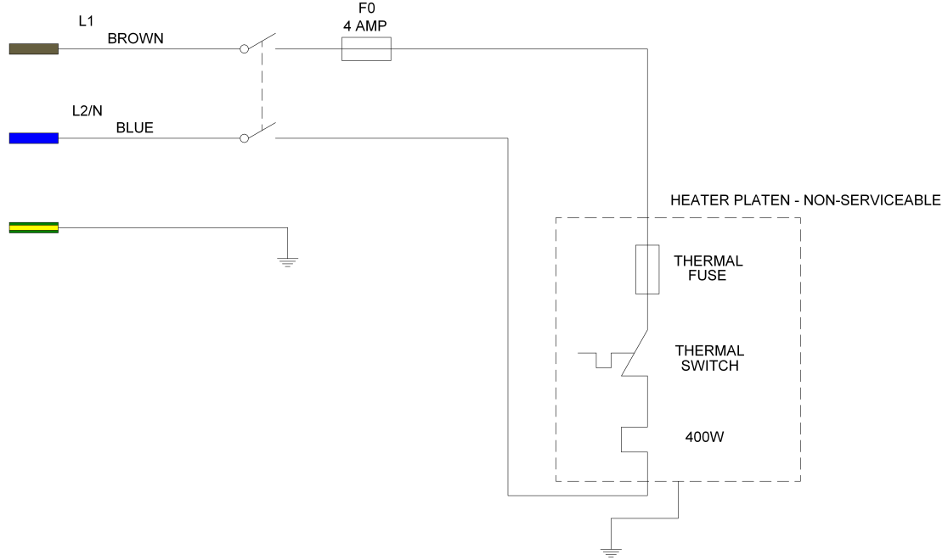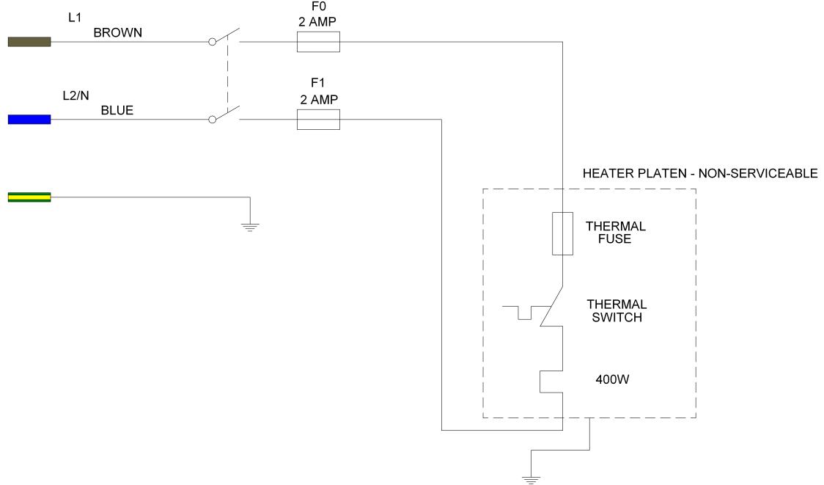

Wiring diagram

**1-60-120V**

**REF. W/D 1308C12002**

**1-60-230V**

**REF. W/D 1308C12000**

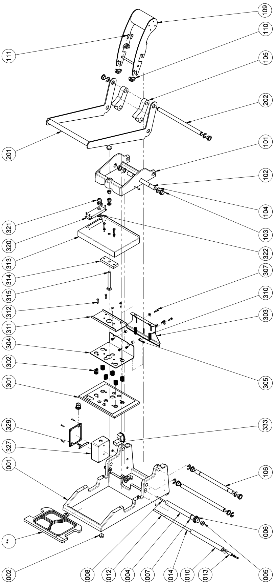

Diagram

Type to enter text

**ITEM NO PART DESCRIPTION PART NUMBER**

001 Base 1308-0015-301

002 Bumper-Rubber 5902-0035

004 Tube-Aluminum 7/8” O.D. 4639-1414-1116

005 Bearing-Roll End 5252-3002

006 Guide-Roller Film 1908-0041

007 O-ring 6909-3211

008 Rod-Film Dispensing 1308-0018

010 Tube-Film Shaft 1308-0016

012 Roller-Pinch 1308-0048-1

013 Spacer-Pinch Roller 1308-0049-1

101 Arm-Center 1308-0014

102 Shaft-Center Arm Link 1308-0001

103 Bearing-Bronze Shaft 5254-3215

104 Clip-E Style (3/4” Shaft) 5840-2841

105 Link-Center Arm 5502-1900

106 Shaft-Mid Pivott 1308-0002

109 Weight-Counter 1308-0042

110 Collar-White Half 1308-0501

111 Screw-Hex Socket Head 1⁄4-28 x 5/88 5725-9500

201 Assembly-Handle 1308-0500-1

202 Shaft-Handle Pivot 1308-0007-001

Parts list

**301 Platen-120V Heater 1308-0061**

301 Platen-230V Heater 1308-0061-002

302 Spring-Compression 7015-2200

303 Blade-Cutting 1308-0011-1

304 Plate-Cutting Blade Mounting 1308-0056

305 Spacer-Blade Mounting 1308-0024-001

307 Screw-Shoulder 1/4 x 3/8 5842-8997

310 Spring-Compression 2” 7014-4203

311 Channel-Spring Backer 1308-0055

312 Screw-Shoulder 1⁄4-28 x 3/4 4560-0908-1201

313 Cover-Heater 1308-0058

314 Bar-Pusher 1308-0057

315 Bolt-Carriage 1⁄2-13 x 4-1/2” 5804-1722

320 Box-Relief 1308-0059

321 Bushing-Strain Relief 5765-1110

322 Nut-Hex Head Lock (PG-11) 5766-7786

327 Enclosure-Electrical 1308-0060-2

329 Brace-Ground 1308-0062

**333 Inlet-Fused Power w/ Switch (1 pole) 5746-7910**

333 Inlet-Fused Power w/ Switch (2 pole) 5746-7911

**334* Fuse-5 x 20 mm (4Amp) 5725-9571**

334* Fuse-5 x 20 mm (2Amp) 5725-9500

**335* Drawer-Fuse (1 pole) 5746-7950**

335* Drawer-Fuse (2 pole) 5746-7951

* **Item Not Shown**

**Bold items are required for 120V North American sale**

Parts list (continued)

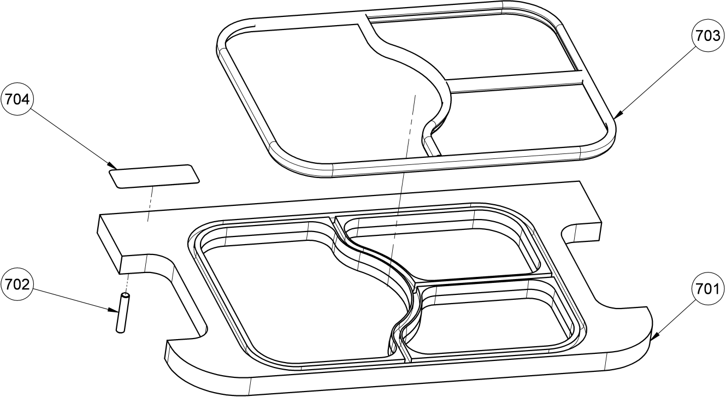

**MODEL 1308 TRAY CARRIER PARTS LIST**

**ITEM NO PART DESCRIPTION PART NUMBER**

701* Carrier-Tray 3 Compartment 1308-0013-0003

702 Pin-Dowel 3/16” x 1” 5835-6471

703** Cushion-White Silicone Extruded 6516-0028

704 Nameplate-“US Patent 5,791,120” 6402-1014

* Tray carries do not come with stock units. They are ordered separate and customized based on the tray that is being used in the sealing operation.

** Cushions differ from tray carrier to tray carrier. The cushion that is used is determined by the engineer during the design process.

FOR SERVICE PARTS CALL SOLPAK AT 1-877-476-5725

Model 1308 carrier

PARTS

Oliver Products Company (Oliver) warrants that if any part of the equipment (other than a part not manufactured by Oliver) proves to be defective (as defined below) within one year after shipment, and if Buyer returns the defective part to Oliver within one year, Freight Prepaid to Oliver’s plant in Grand Rapids, MI, then Oliver, shall, at Oliver’s option, either repair or replace the defective part, at Oliver’s expense.

LABOR

Oliver further warrants that equipment properly installed in accordance with our special instructions, which proves to be defective in material or workmanship under normal use within one (1) year from installation or one (1) year and three (3) months from actual shipment date, whichever date comes first, will be repaired by Oliver or an Oliver Authorized Service Dealer, in accordance with Oliver’s published Service Schedule.

For purposes of this warranty, a defective part or defective equipment is a part or equipment which is found by Oliver to have been defective in materials workmanship, if the defect materially impairs the value of the equipment to Buyer. Oliver has no obligation as to parts or components not manufactured by Oliver, but Oliver assigns to Buyer any warranties made to Oliver by the manufacturer thereof.

This warranty **does not** apply to:

1. Damage caused by shipping or accident.
2. Damage resulting from improper installation or alteration.
3. Equipment misused, abused, altered, not maintained on a regular basis, operated carelessly,or used in abnormal conditions.
4. Equipment used in conjunction with products of other manufacturers unless such use is approved by Oliver Products in writing.
5. Periodic maintenance of equipment, including but not limited to lubrication, replacement of wear items, and other adjustments required due to installation, set up, or normal wear.

6. Losses or damage resulting from malfunction.

The foregoing warranty is in lieu of all other warranties expressed or implied AND OLIVER MAKES NO WARRANTY OF MERCHANTABILITY OR FITNESS FOR PURPOSE REGARDING THE EQUIPMENT COVERED BY THIS WARRANTY. Oliver neither assumes nor authorizes any person to assume for it any other obligations or liability in connection with said equipment. OLIVER SHALL NOT BE LIABLE FOR LOSS OF TIME, INCONVENIENCE, COMMERCIAL LOSS, INCIDENTAL OR CONSEQUENTIAL DAMAGES.

Warranty

Warranty procedure

1. If a problem should occur, call SOLPAK at 1-877-476-5725 ext. 221
2. A Solpak partner will determine if the warranty will apply to this particular problem and inform you of the actions to take (technician, exchange,…).
3. A replacement 1308 can be made available to you in the event your unit has to be repaired in our service centre.

***The Solpak team***

***thanks you for your trust!***