OLIVER TRAYSEALER

Model 1908 E

User’s operating and instruction manual

Index
Section description Page

QUICK SPECS 5
INTRODUCTION AND DESCRIPTION 5
INSPECTING 6
SAFETY 7
MACHINE PLACEMENT AND UTILITIES 8
MACHINE COMPONENTS 9
START-UP AND OPERATION 15
TECHNICAL SPECIFICATIONS 18
CLEANING AND MAINTENANCE 19
TROUBLESHOOTING 23
WARRANTY PROCEDURE 27

QUICK SPECS

Weight 330 lbs
Overall Dimensions 30” W x 64” L x 50” H
Loading Station 3 tray carriers
Electrical 1 phase, 60 Hz, 115 VAC, 15 amps
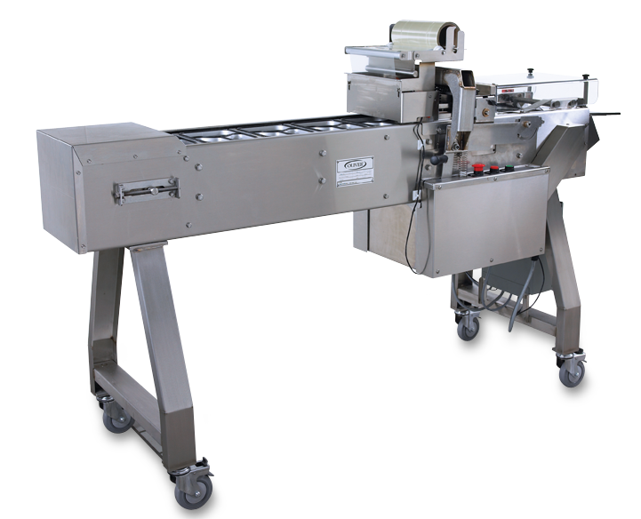

INTRODUCTION AND DESCRIPTION

The OLIVER Model 1908 Lidder has been designed and manufactured to provide a high quality machine that is a cost effective approach to producing film lidded trays. The machine can be operated with a 120 V.A.C. outlet. The Model 1908 is an automated system capable of producing a high volume, but it is easy to operate and requires minimal space.

The machine consists of a conveyor system that transports the filled trays; a film feed system, a heated platen and a film cutter unit. These are all packaged together in a stainless steel framework that also houses all the necessary controls. The conveyor is intermittent motion and is capable of running speeds of 20 to 27 packages per minute.

INSPECTING

MODEL 1908

Upon receipt of Machine, inspect the exterior for damage. If damage is noted,
Indicate damage on the Freight Bill and immediately contact the freight Carrier and notify them of the damage. Have a freight claim filed. This must be done at the Recipient’s location and not at the Shipper’s Location.

Remove the tie-downs that hold machine to the skid. Lift the machine off the skid in a safe manner. Remove tape and tie bands that were used to hold components for shipment.
SAFETY

Various safety devices and methods of guarding have been provided on this machine. Do not operate the machine with guards removed and do not tamper with safety devices. It is essential that machine operators and maintenance personnel observe the following safety precautions. Improper installation or operation of this equipment may cause injury to personnel or damage to equipment.

- Before operating the OLIVER Model 1908 Lidder read through this manual. Never allow an untrained person to operate this machine

WARNING
- WARNING PINCH POINT: Keep hands out of machine. Always be sure the machine has been unplugged from power before cleaning or servicing.

- CAUTION HOT: The heater platen and parts around it are very HOT! Caution must be used to protect yourself and others.

- In addition to these general safety instructions, follow the specific instructions given throughout this manual.

MACHINE PLACEMENT AND UTILITIES

MODEL 1908

Decide on a suitable location for the machine. This location should have ample room to work around all sides of the machine. Once the machine is in the location where it will be used, the brakes on the casters should be locked by stepping down on the brake locking lever. To unlock, lift the lever with your foot. Do not attempt to move machine with casters in locked position.

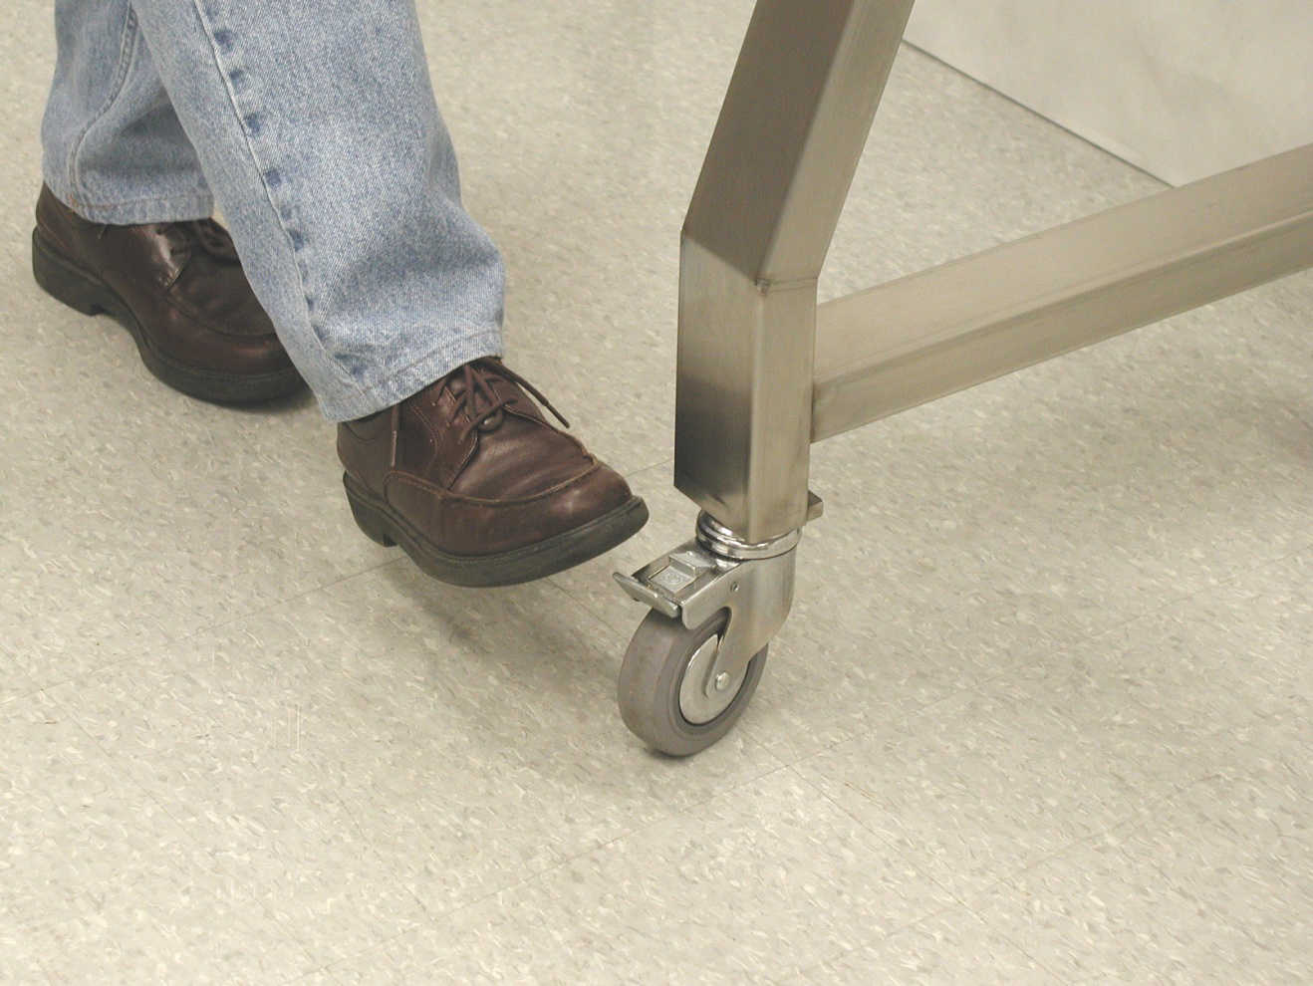
LOCKING LEVER

The machine operates on 120 V.A.C., 60 Hz, 15 Amp electrical power. It is recommended that this power be supplied by an overhead drop to prevent the cord from becoming a trip hazard.
MACHINE COMPONENTS

Before proceeding further, take a moment to familiarize yourself with the identification of the machine components as shown in the illustrations below.

Film Roll Holder with Film Roll and Roll Weight Installed.
Film Roll Guide
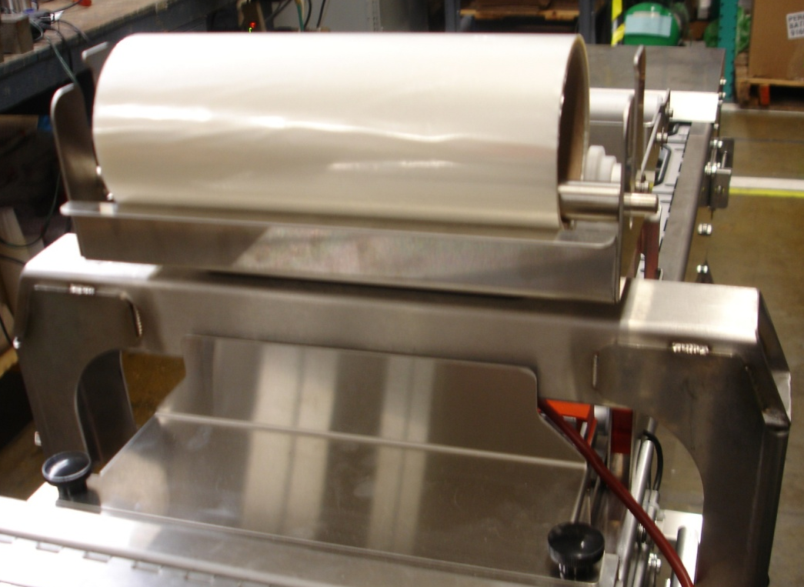
Film Roll Weight
Heat shield

Emergency Stop, Stop, and Start Buttons

Heat Platen Lift Spring

Drive and Platen Release Locations and Speed Control Location

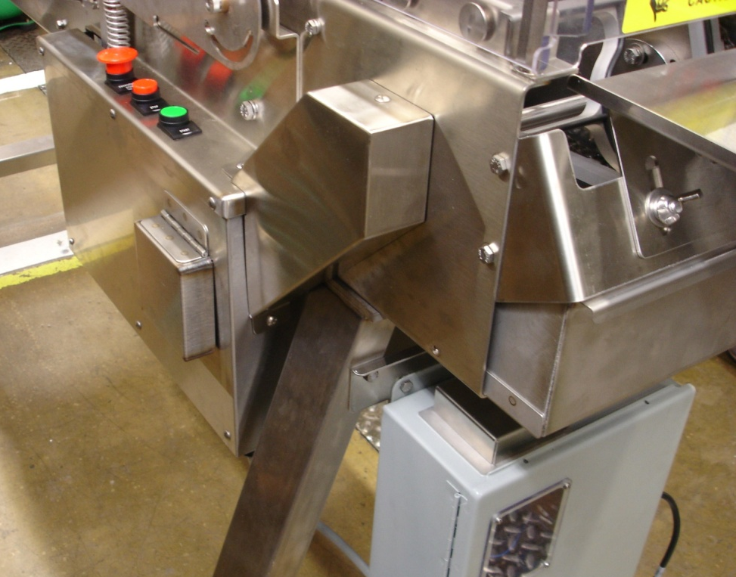
Bottom Pan
Speed Control knob (Under Cover)
Conveyor release knob (Under Cover)

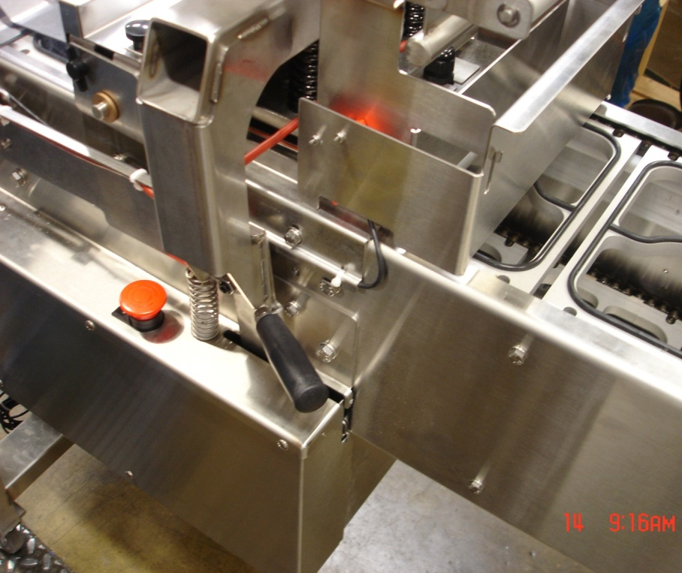
In-feed guard (with safety switch)
Rear Emergency Stop Button
Heater Platen release lever (Pull to release)

Out feed or discharge area

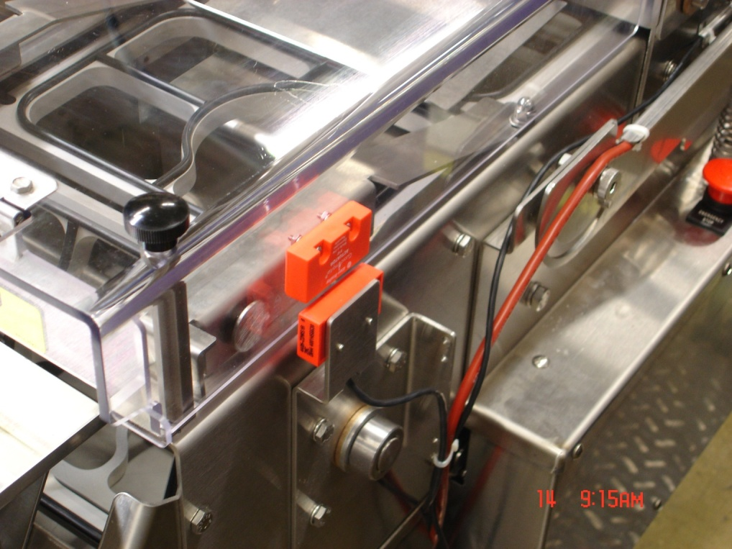
Discharge Cover (with safety switch)

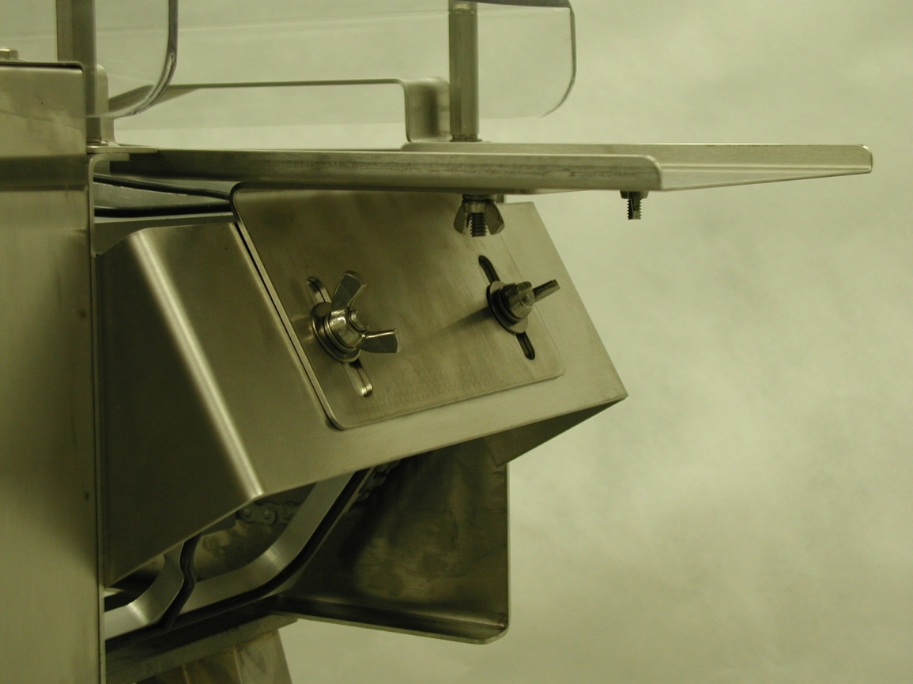
WING NUTS
LOOSEN TO ADJUST
TABLE UP OR DOWN
THESE WING NUTS ALLOW FOR MOVING THE DISCHARGE TABLE IN AND OUT TO CLEAR THE TRAY CARRIERS
DISCHARGE TABLE

Tray Carriers

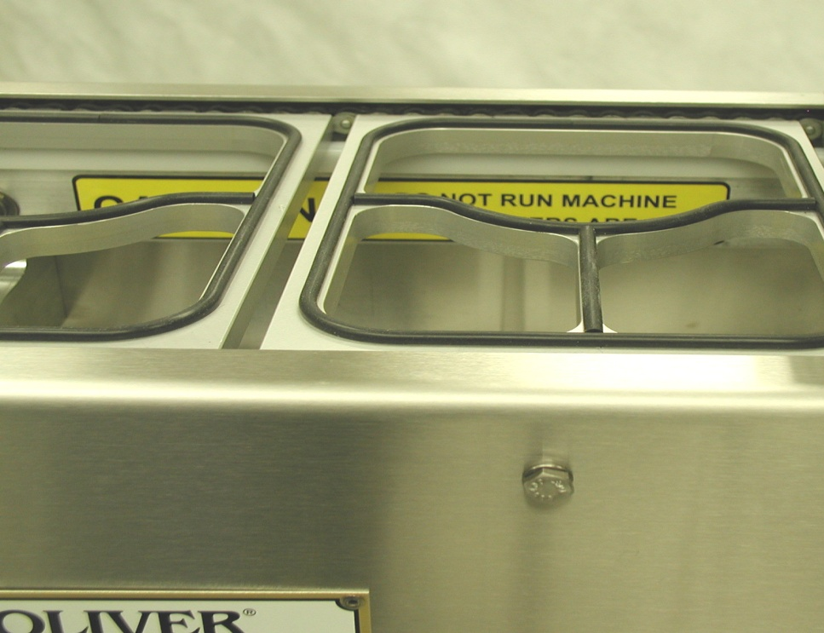
TRAY CARRIER
RUBBER GASKET

Film Cut-Off

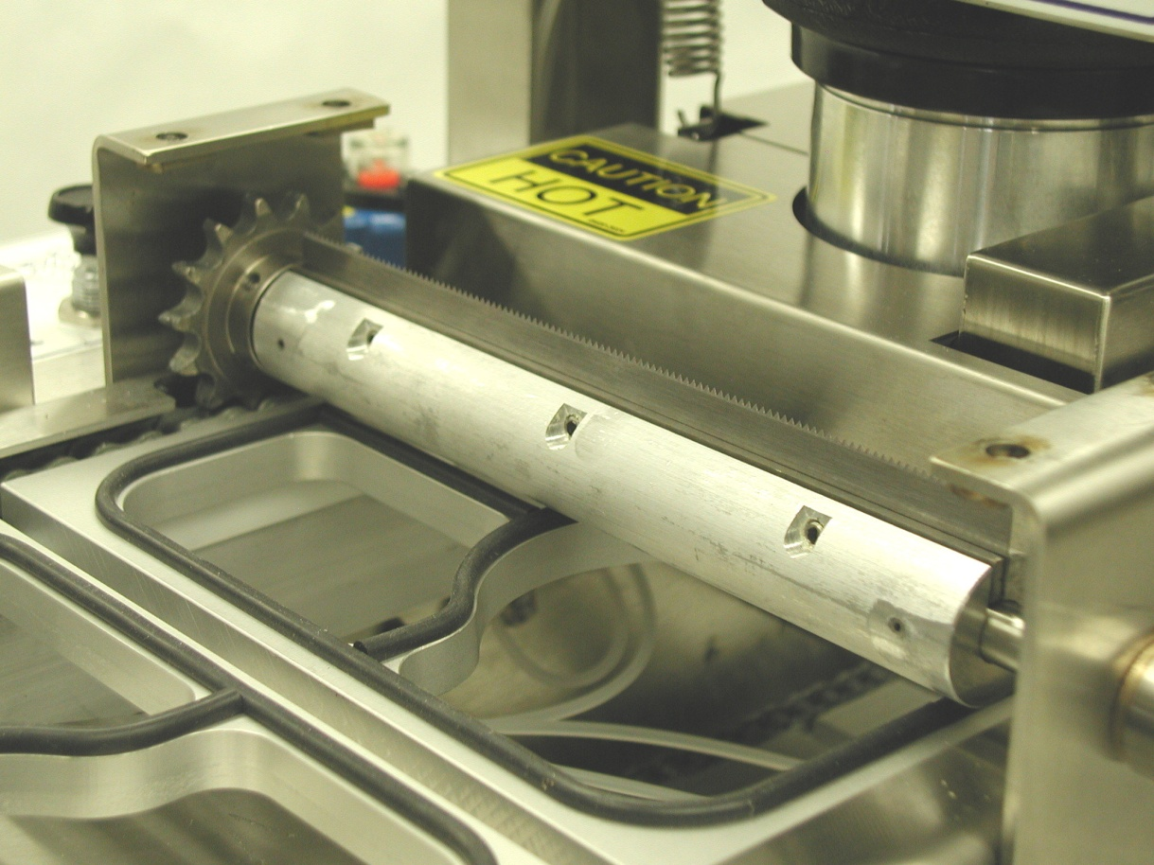
CUTTER ASSEMBLY
CUTTER BLADE
DRIVE SPROCKET

Conveyor Chain Tension Adjustment Mechanism

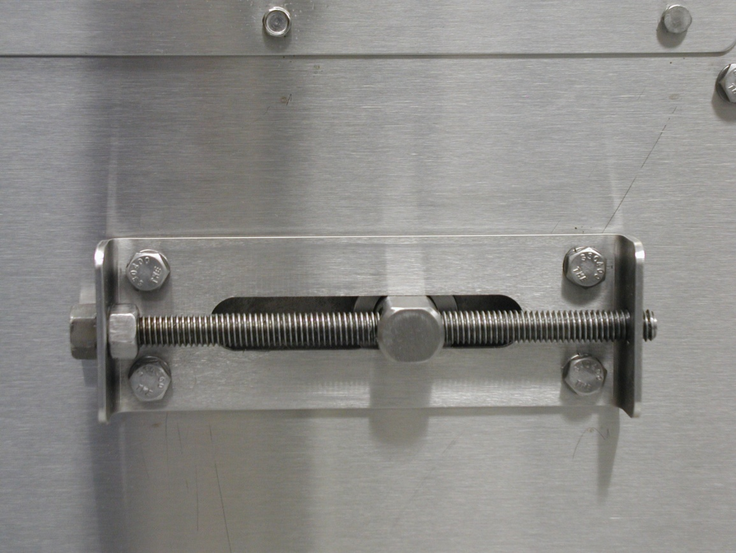
ADJUSTMENT SCREW
LOCKING NUT

START-UP AND OPERATION

To turn the machine on, plug in the power cord and wait 15 minutes to allow the heated platen to reach operating temperature before attempting to seal trays.

Run the machine without trays and film to make sure everything is cycling properly.

- VERIFY THE CONVEYOR IS READY TO OPERATE: Remove any extra items that may have been placed on the conveyor and verify people are clear of the trays and tray carriers. The guards (in-feed gate and clear exit cover) must be in place and the emergency stop buttons must be in the up position (twist and allow the button to pop up to reset).

- VERIFY THE SEALING PLATEN IS CONNECTED TO THE PULL-DOWN ARMS: Lift the black handles and hook the roller on the platen arch. This may be left undone if it is desired to run the conveyor without operating the sealer.

- PUSH THE GREEN “RUN” BUTTON.

- PUSH THE RED “STOP” BUTTON TO STOP THE MACHINE WITH THE SEALING PLATEN UP (NOT PRESSING ON A TRAY OR TRAY CARRIER).

NOTE: USE THE EMERGENCY-STOP BUTTONS OR THE SAFETY GATE SWITCHES TO STOP THE MACHINE IN EMERGENCY SITUATIONS ONLY. These switches act immediately and do not wait for the sealing cycle to finish. This will leave the heater in contact with the tray resulting in over-heated packaging materials. Stopping the machine improperly will result in a shortened machine life.

- TO CHANGE THE CONVEYOR SPEED: Adjust (turn) the black knob on the top of the electrical box (lift the small stainless steel cover to access).

IMPORTANT NOTES

- Never run the machine with trays without film. Doing so can possibly cause a jam because the trays can stick to the heated platen and be pulled out of the tray carriers.

- Adjusting the speed of the conveyor will also change the dwell time of the sealer. Excessively slow speeds will result in excessively sealed trays.

- If the conveyor becomes jammed, stop the conveyer and turn the power off. The conveyor drive release knob may be pulled to allow manual movement of the conveyor to aid removing jammed materials.

- Load the film on the film stand as shown on the film-threading diagram located on the machine and also shown in the diagram below.

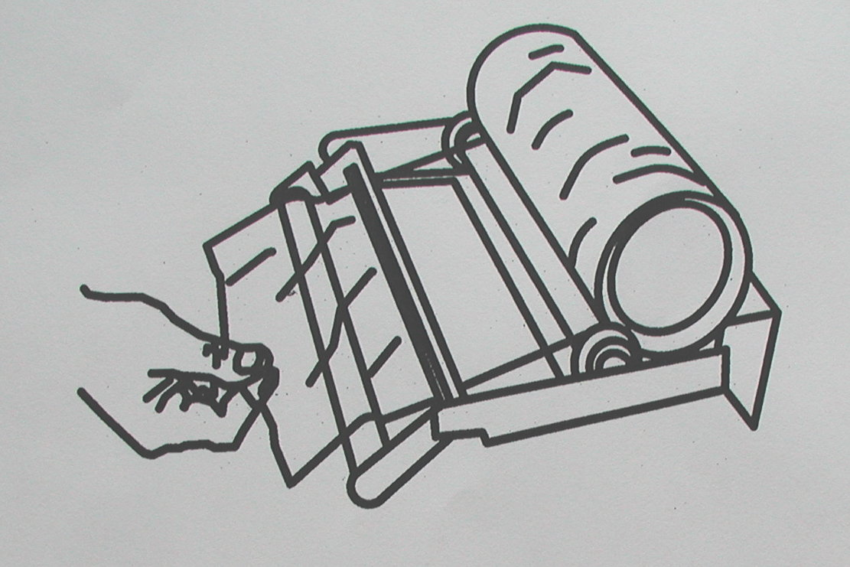

NOTES

- The adhesive side of the film can be determined by pinching a fold and rubbing the lid material against itself. Test both sides of the lid. The rough or tacky side of the lid will be the adhesive side. The film supplied by Oliver is wound with the adhesive side toward the inside of the roll. If the film is loaded in accordance with the “FILM FEED” diagram it will be positioned properly for applying the adhesive side of the film to the flange of the tray. If the film is loaded improperly, it can cause the adhesive side to come in contact with the heated platen and the film to stick to the heated platen. If this happens, the platen will need to be cleaned.

- To thread the film through the machine, pull enough film off the roll so that you can insert it into the slot between the tray carrier that is partially under the film stand and the carrier that is upstream from that. After the film is hanging down underneath the tray carrier, reach through the tray carrier and pull the film down so that it touches the tray carriers underneath that are returning to come back up on top. Then insert a tray into the tray carrier next to the film and cycle the machine one time. This should seal the film to that tray and you can now fill the rest of the conveyor with filled trays and begin running.

- The film dancer bar must move freely up and down.

- If you miss putting a tray in the machine it will not cause a problem, but the film will be sealed to the top of the empty tray carrier. Let the machine continue to run until that tray carrier goes around the bottom of the conveyor and comes back up on top, then remove the piece of film.

- It is important that the roll of film is centered on the conveyor. There are white plastic film guides on either side of the film roll. These guides can be adjusted from side-to-side by pushing them with your hand. If the film is not centered, move both guides toward the side that the film needs to go to. It may take a little bit of running time before you can tell if the film is in the correct position.

- Place filled trays in tray carriers. Take care to avoid spilling food product on the flange of the tray. Contamination of the flange can result in poor heat seals.

- After a few trays come out of the machine, stop and inspect the acceptability of the seals. If the seals are not acceptable or the trays do not come out of the machine smoothly, refer to the trouble shooting guide.

- The machine can be stopped at any time by pushing the stop button down. When started again, the machine will pick up sealing where it left off.

NOTE

- IT IS NOT RECOMMENDED TO LEAVE THE MACHINE PLUGGED IN IF IT IS GOING TO BE OUT OF OPERATION FOR AN EXTENDED PERIOD OF TIME.

TECHNICAL SPECIFICATIONS

Model 1908

Tray Capacities: 6-3/8” (162mm) by 8.5” (216mm) maximum top-outside-
dimensions of the tray.

Temperature Range: Factory preset to approx. 300 degrees F.

Weight: 330 LBS.

Electrical: 120 VAC, 15 Amps, Single Phase, and 60 Hz
Air Requirements: 6 CFM @ 80 PSI

Machine Dimensions: 17” (43.2 cm) Wide x 64” (162.5 cm) Long x 45” (114.3 cm) High

CLEANING AND MAINTENANCE

WARNING
Disconnect the power from the Model 1908 and allow the unit to cool before performing cleaning and/or maintenance procedures.

These cleaning recommendations are not meant to replace or supersede plant-standard manufacturing procedures or regulatory requirements. Do not immerse, hose down, pressure wash, or otherwise soak electrical switches, electrical control box, mechanical drive box, and electrical connections. Avoid getting these areas wet. If your cleaning procedure involves liquid amounts greater than the use of a damp cloth, protect these areas by shielding with plastic bags.

- Heater Platen Cleaning:

CAUTION

  - CAUTION HOT: The platen and surfaces around it may be very HOT! Care must be taken to protect yourself and others. If the platen will be cleaned while it is still hot make sure hand protection is used to prevent skin contact with the platen.

If food product comes in contact with the surface of the platen it tends to burn on and become hard. This results in an irregular surface on the face of the platen that can result in poor seals. If this happens, it will be necessary to remove this burnt on food material.

  - Remove the In-feed guard.

  - Tip the film roll holder forward until it is resting on the side rails of the machine.

  - Remove the discharge cover and heat shield by removing the 4 black plastic screw knobs on top of the covers and lift the covers off.

  - Release and tip the heater platen up by pulling the large black handles and rotating the heater platen upwards until it is against the stops. The bottom of the heater plate will be easily accessible.

  - Clean any food residue off the heater platen. When cleaning the surface of the platen care must take to avoid scratching or gouging the surface. DO NOT SCRAPE THE SURFACE OF THE PLATEN WITH SHARP OBJECTS AND AVOID THE USE OF METAL TOOLS. Instead use a plastic or soft-metal scouring pad such as Scotch Brite® or Chore Boy® brands provide a safe and effective means of cleaning the heated platen. Wipe all surfaces with a sanitizing agent after cleaning.

- Tray Carrier Cleaning:

The tray carriers should be removed and cleaned daily. It is better to remove them for cleaning rather than trying to clean them in the machine. The tray carriers can be placed in your dishwasher for cleaning if you desire. Care should be taken so that the rubber gaskets do not become damaged.

  - Disconnect the conveyor from the drive unit by lifting the cover on the side of the machine and pulling the knob out. The knob will stay out if it is twisted ¼ turn while pulling. This allows the conveyor to be moved manually.

The carriers should be removed in the middle of the in-feed area on the top of the conveyor.

  - Lift up on two tray carriers next to each other and push one to one side while pulling the other it to the other side. This spreads the chains so the pins can be disengaged. Completely remove the two carriers as shown.

The picture below shows how to remove the tray carriers.

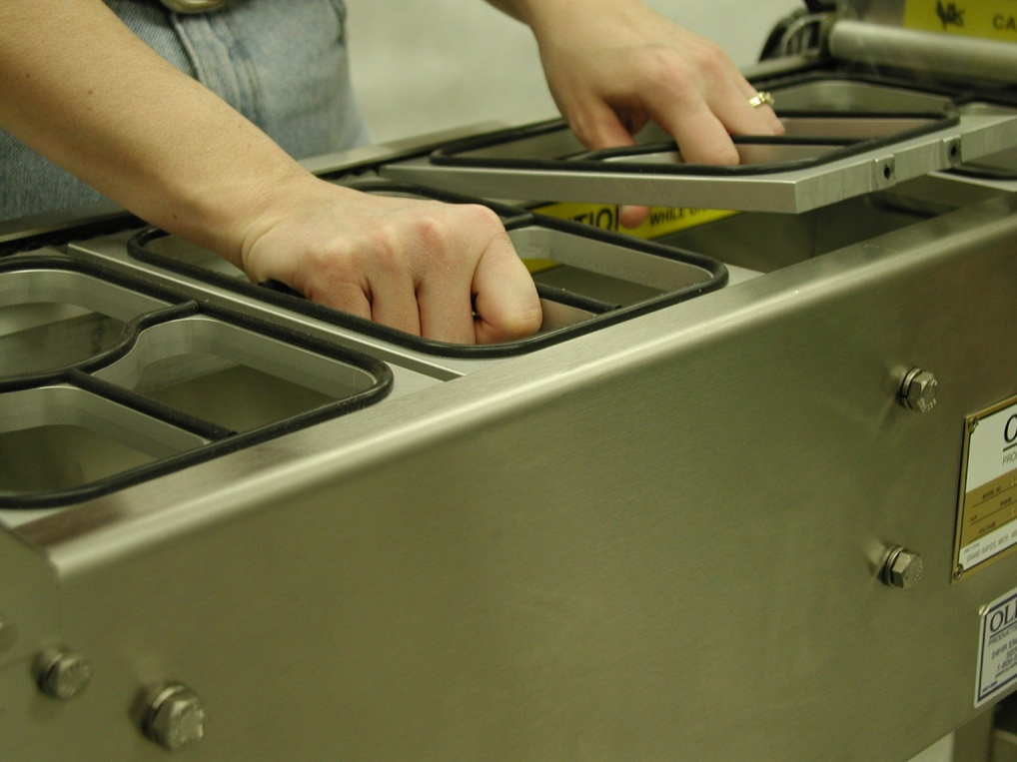

  - As the carriers are removed, the conveyor must be pulled forward to keep getting to the remaining carriers. To move the conveyor forward, grasp a tray carrier toward the infeed-end of the machine and pull the conveyor forward. This must be done with the conveyor disconnected from the drive (step 2.1).

  - Wipe all surfaces with a sanitizing agent after cleaning.

  - Replace the tray carriers after cleaning the remainder of the machine.

Note: Look for a white painted chain link to center on the side of the first tray carrier re-installed to get the tray carrier/ chain timing correct.

Note: When replacing the tray carriers, it is extremely import to make sure that all four pins on the conveyor chains are fully engaged in the holes of the tray carrier. If the tray carriers are put in on an angle because the pins are not engaged on one side, it could cause damage to the cutter assembly.

  - Re-engage the conveyor drive by twisting the release knob until it snaps in. Move the conveyor manually until the pin locks in and prevents further movement.

- Clean the remainder of the machine:

  - Remove the two bottom pans by sliding them toward the discharge end of the machine. Note: the pans may need to be jostled up and down slightly to get them over bolt heads and other obstacles.

  - Clean the cutter assembly with a mild cleaner or sanitizing solution and a damp cloth.

NOTE

The use of plastic or soft-metal scouring pads such as Scotch Brite® or Chore Boy® brands provide a safe and effective means of cleaning the cutter assembly. Wipe all surfaces with a sanitizing agent after cleaning.

  - Clean the pans and remaining surfaces of the machine with a mild cleaner or and a damp cloth. Wipe all surfaces with a sanitizing agent after cleaning.

- Conveyor Chain Maintenance

  - Once a month the conveyor chains should be lubricated with vegetable oil such as cooking spray. If you use hose-down cleaning, this should be done twice a month.

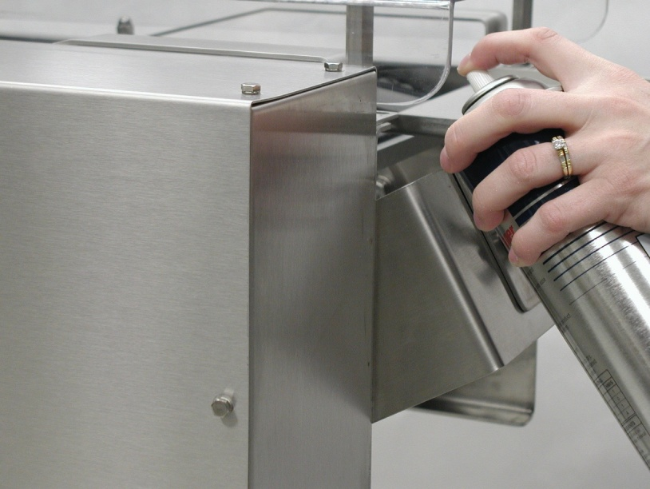
SPRAY CHAINS WHILE MACHINE IS CYCLING
SPRAY CHAINS WHILE MACHINE IS CYCLING
SPRAY CHAINS WHILE MACHINE IS CYCLING

  - Once a month the conveyor chains should be checked for proper tension. The tension can be checked by lifting the lower tray carriers at the middle of the machine. If you can easily lift them up more than 3 inches, the chains are too loose and should be tightened by adjusting the tensioners at the infeed-end of the machine. Loosen the locking nuts and turn the adjusting screws clockwise to tighten the chains then retighten the locking nut. It is important to adjust both sides equally. The easiest way to do this is to count the turns that you tighten one side and then do the same on the other side. The best method is to adjust each side in ¼ turn increments and then recheck the chain tension.

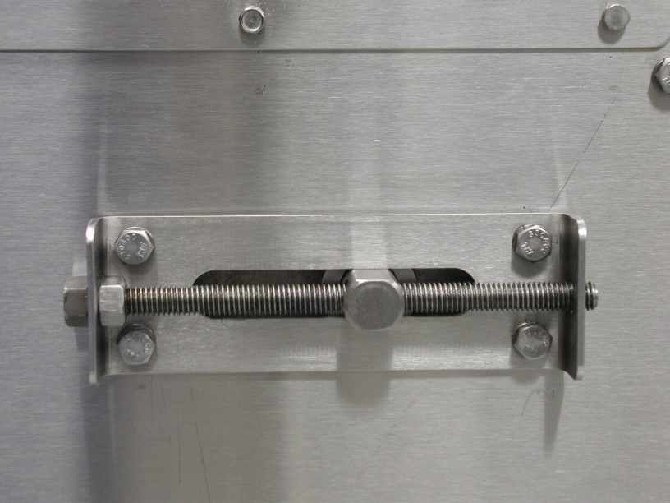
LOCKING NUT
ADJUSTING SCREW

TROUBLESHOOTING

There are no user serviceable parts on your OLIVER Model 1908 Lidder except for the cutter blade. Should you experience problems with your machine call the Oliver Products Company 24 Hour Emergency Service number @ 1 800-253-3893. Please have the serial number of your machine available to give to the Customer Service representative.

Before calling for assistance please check the list below to see if the problem you are experiencing is listed. If it is, try the corrective action items listed for that problem before calling for assistance.

OPERATION ISSUES:

Symptom: | Corrective Action:
Machine does not power-up (does not run and/or the heater platen does not get hot) | - Verify the machine is plugged in to a working outlet.  - If the platen does not heat, unplug the power and remove and inspect the fuse (located in the electrical panel, see section 4). Replace if necessary (see parts list).
Machine receives power, but the conveyor does not move when the start button is pushed. | - Verify the two e-stop buttons are not engaged (pushed down). Twist the button to release it to the ready to run position.  - Verify the in-feed guard is installed in the correct position (stainless steel gate hung in front of the heater platen).  - Verify the discharge cover is installed correctly (plastic cover).  - Verify the speed control knob is turned to 75% to 100% of the speed range.
Conveyor does not move when the start button is pushed and steps 1-4 (above) have been taken. | - Turn the speed up to 100%. Look in the window of the electrical box under the conveyor out-feed. A green or red light should be visible.  --A green light indicates the motor is receiving power and should be able to run. If only a green light is visible, go to step 12.  --A red light indicates a mechanical jam— turn off the main power immediately. Go to step 8.  --No light indicates power is not available to the motor because a guard, e-stop switch, or main power switch is tripped. Go to step 13.
A mechanical jam is preventing the conveyor from moving as indicated by a red light in the electrical box window. | - Mechanically disconnect the indexer drive from the conveyor by pulling the disconnect knob and turning it 90 degrees (1/4 turn) so it stays out.  - Mechanically disconnect the platen by pulling the large black plastic handles. Allow the platen springs to hold the platen up off the conveyor, but do not remove guards and lift it as you would for cleaning.  - Manually pull the conveyor. If it pulls freely, the problem is in the transmission box (Call for service). If the conveyor does not move, look for a jammed tray, an incorrectly installed and/or wedged tray carrier, excessive food build-up, excess film wrapped around a conveyor part or the cutter, or excessive chain tension.  - If no correctable cause is found for the jam, call for service.
The drive system appears to be working correctly as indicated by a green light in the electrical box window, but the conveyor does not move. | - Verify the drive is mechanically engaged with the conveyor—Check the disconnect knob—make certain it is not pulled out (twist the knob and allow it to snap in). Give the conveyor a pull until it “hooks up” (cannot be manually moved further).
The drive system is not receiving power as indicated by the absence of lights visible in the electrical box window. | - Recheck steps 1-6.  If step 13 does not remedy the problem, call for service.

SEALING and TRAY BEHAVIOR ISSUES:

Poor seal quality | - Verify that the platen is heated by placing your hand near the platen and try to detect if there is heat radiating out from it-DO NOT TOUCH THE PLATEN  - Check to see if the platen is dirty  - Check rubber gasket on tray carriers for damaged or missing pieces  - Check to see that the film is centered on the tray  - Check to see that the heat seal dwell is set properly  - Make sure that the tray flanges are not contaminated with product  - Verify the film is routed so the adhesive coated side is oriented against the tray. See “Start-Up and Operation” section step 6.
Film does not cut | - Inspect the cutter blade for wrapped film-You must remove the cutter guard to do this and if there is film wrapped around it the film must be cut away and pulled off- THE CUTTER BLADE IS SHARP, DO NOT TOUCH-REMOVE ELECTRICAL POWER PRIOR TO REMOVING GUARD.  - Inspect to determine if the cutter blade is present.  - Inspect to determine if the cutter blade is dull.  - Inspect to determine if the cutter blade is dirty.
Film is not centered on tray | Adjust the plastic guides on the film holder so that the film is centered over the trays
Trays do not exit the machine smoothly. | Adjust the position of the discharge table. Loosen the thumb screws and move the table. Make the table height slightly lower than the bottom of the trays as they exit the conveyor. Keep the gap between the table top and the conveyor small enough to prevent the trays from tipping down between the conveyor and the discharge table. (Reference the labeled photograph in the “Machine Components” section of this document.)  Verify the film is being cut effectively, if not, see above.

WARRANTY PROCEDURE

- If a problem should occur, call SOLPAK at 1-877-476-5725 ext. 221.
- A Solpak partner will determine if the warranty will apply to this particular problem and inform you of the actions to take (technician, exchange,...).
- Please use your 1308 backup until your 1908 has been repaired.

The Solpak team
thanks you for your trust!

